Activity A: Research

The Influence of Materials and Shape on Sensory Expectations

Declan Heard

# Material & Shape on Sensory Expectations

<https://www.sciencedirect.com/science/article/pii/S095032931831036X>

How our design meets the market need and how we have addressed environmental and inclusivity issues

# Market Need

Keeps Contents Hot for several hours – Two vacuum insulated layers lower heat loss through convection and conduction.

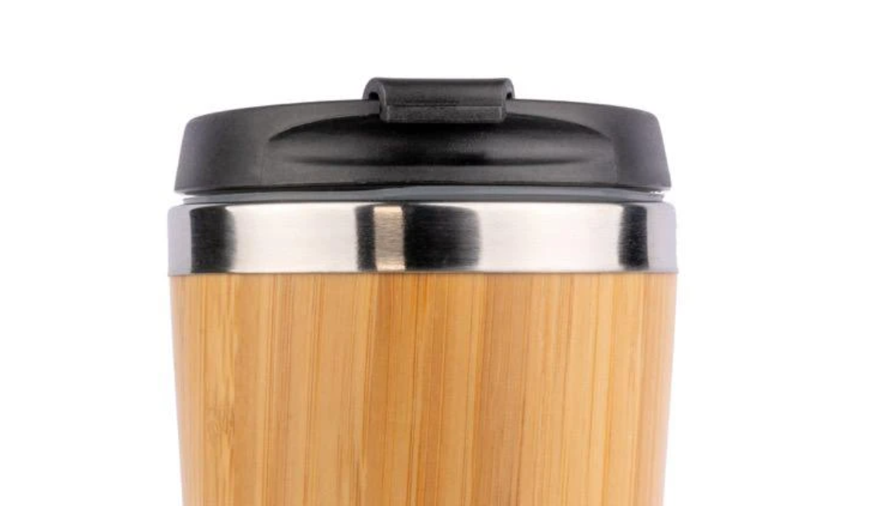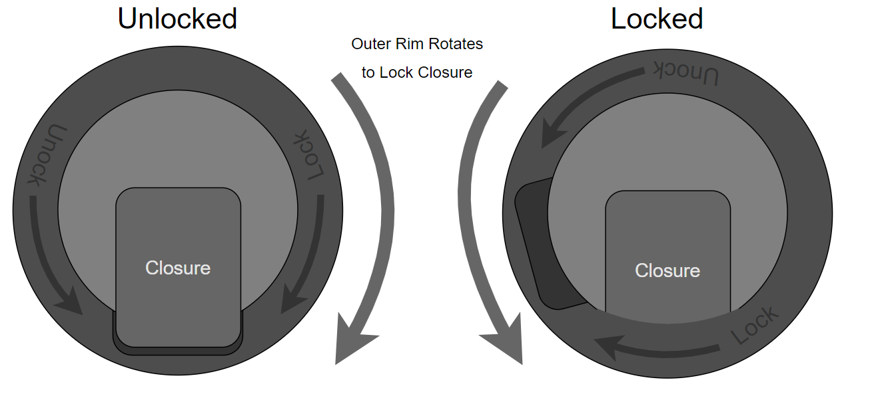Spill Proof & Easy to transport – Lid features a screw on mechanism that will not fall off if tipped. The closure for the drinking orifice will have a levered construction that is locked in place by rotating the outer rim of the lid

Allows mug to be placed in backpacks without worrying about spillage or the cap being knocked off.

Easy to use drinking orifice – Extra wide closure for lid to maximise area in contact with mouth for a superior drinking experience.

Neutral Colours – Wood effect wrap makes travel mug blend into surroundings in woodlands & bird habitats

Durable & Resistance to Environment & general use inc dishwashing – Stainless Steel construction is resistant to acidic drinks, easy to clean and dishwasher safe. Wood effect wrap and BPA free plastics like Polypropylene are hard waring and dishwasher safe.

# Environmental

This product uses materials that are recoverable and recyclable. Waste Stainless Steel retains a significant amount of value as a feedstock for the metal industry, For any stainless steel products on the market today there is an approximate 60% of recycled material.

“Stainless steel is made up of:

25% Old scrap such as end of life products

35% New scrap which is returning from production

40% New raw materials added”

(British Stainless Steel Association, 2021)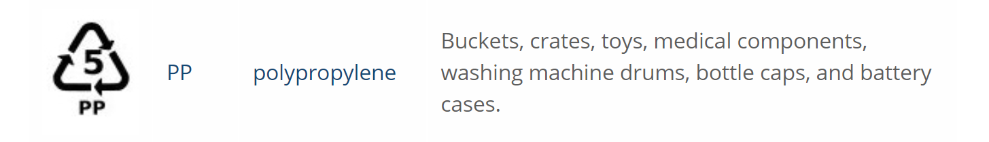

(British Plastics Federation, 2021)

# Inclusivity

Alternative Lid could incorporate a drinking straw, both non-spillable and accessible for people with muscle disorders and low swallowing strength. Straw exterior would be made from BPA free plastic like Polypropylene, which can be heated to temperatures high enough to disinfect without damage, interior straw could be silicon as this is dishwasher safe.

(Kidly, 2021)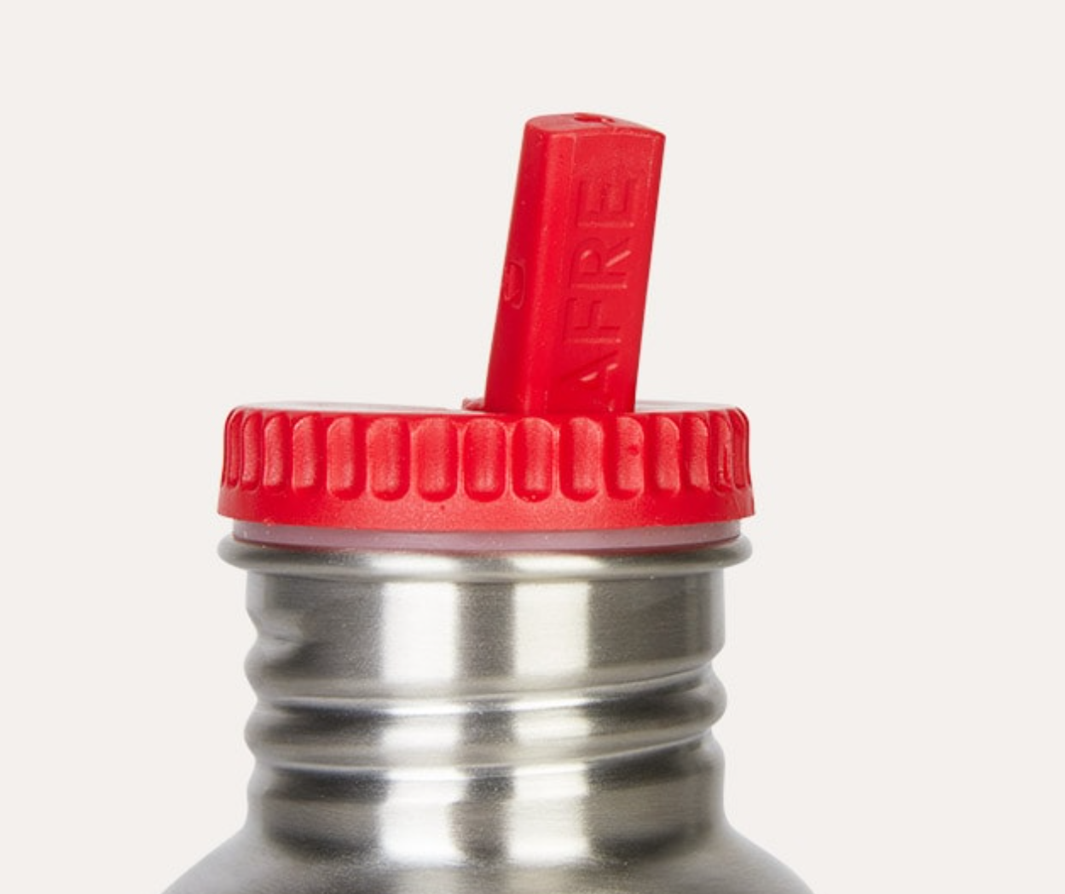

# References

British Plastics Federation. (2021). *Plastic Recycling*. Retrieved July 24, 2021, from BPF.co.uk: https://www.bpf.co.uk/sustainability/plastics_recycling.aspx

British Stainless Steel Association. (2021). *ENVIRONMENTAL ASPECTS OF STAINLESS STEEL*. Retrieved June 24, 2021, from BSSA.org: https://bssa.org.uk/bssa_articles/environmental-aspects-of-stainless-steel/

Kidly. (2021). *Non Spill Drinking Spout*. Retrieved July 24, 2021, from Kidly.